Could not use stylgan or stylegan 2, the training times are too long. https://github.com/NVlabs/stylegan

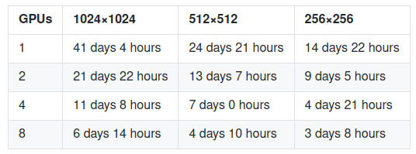
SPADEs

